(Passenger waybill – recto)
(To be worded in the official language or several of the official languages of the State of vehicle regristration)

(State in which the document is issued) – Distinguishing sign of the country –

Book No Waybill No

1
2
3 |  |  |  |  |  | 1  2  3
4 | Type of service (put a cross in the appropriate box and add the required supplementary information)
 | A  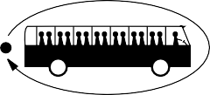 |  |  |  |  | 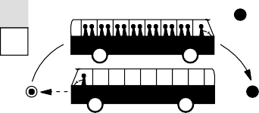  B ★ =  ★
 | C Outward journey unladen in order to take up a group of passengers and transport them to the country of vehicle  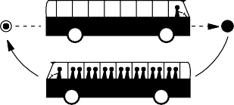  registration  ★  ★ =  = |  |  |  |  | The passengers were:
assembled, under a contract of carriage made on
C1 with (travel agency, association, etc.).
They arrive(d) on in the territory of the ECMT Member country where they are to be taken up, copy of the contract of carriage or equivalent document (cf. Important Notice under 3) is attached.
previously brought by the same carrier on a service referred to in B,
C2 to the country where they are to be taken up again.
The passenger waybill for the previous outward laden journey and unladen return journey is attached.
invited to travel to Cost of transport being borne
C3 by the person issuing the invitation and the passengers constitute a homogeneous
group which has not been formed solely with a view to undertaking that particular journey. The letter of invitation (or a photocopy thereof) is attached.
D Another occasional service (particulars):
Authorization not required because
5 | Itinerary | Étapes journalières
 | Dates |  | from | to |  |  |   km km |  |   Douane
 |  |  |  | Total |  |  | + =

(Passenger waybill – verso)

 |  |  |  | 1 | 22 |  | 43
 |  |  |  | 2 | 23 |  | 44
 |  |  |  | 3 | 24 |  | 45
 |  |  |  | 4 | 25 |  | 46
 |  |  |  | 5 | 26 |  | 47
 |  |  |  | 6 | 27 |  | 48
 |  |  |  | 7 | 28 |  | 49
 |  |  |  | 8 | 29 |  | 50
 |  | 6 |  | 9 | 30 |  | 51
 |  |  |  | 10 | 31 |  | 52
 |  |  |  | 11 | 32 |  | 53
 |  |  |  | 12 | 33 |  | 54
 |  |  |  | 13 | 34 |  | 55
 |  |  |  | 14 | 35 |  | 56
 |  |  |  | 15 | 36 |  | 57
 |  |  |  | 16 | 37 |  | 58
 |  |  |  | 17 | 38 |  | 59
 |  |  |  | 18 | 39 |  | 60
 |  |  |  | 19 | 40 |  | 61
 |  |  |  | 20 | 41 |  | 62
 |  |  |  | 21 | 42 |  | 63
 |  |  |  | Date of completion of waybill |  | Signature of carrier
 |  | 7  8  9 |  | Unforeseen changes  Control stamps if any

