|  |
| --- |
| (To be worded in the official language or several of the official languages of the State of vehicle regristrat]00} |

(Passenger waybill — recto)

Book No

Waybill No

(State in which the document is issued) — Distinguishing sign of the country —

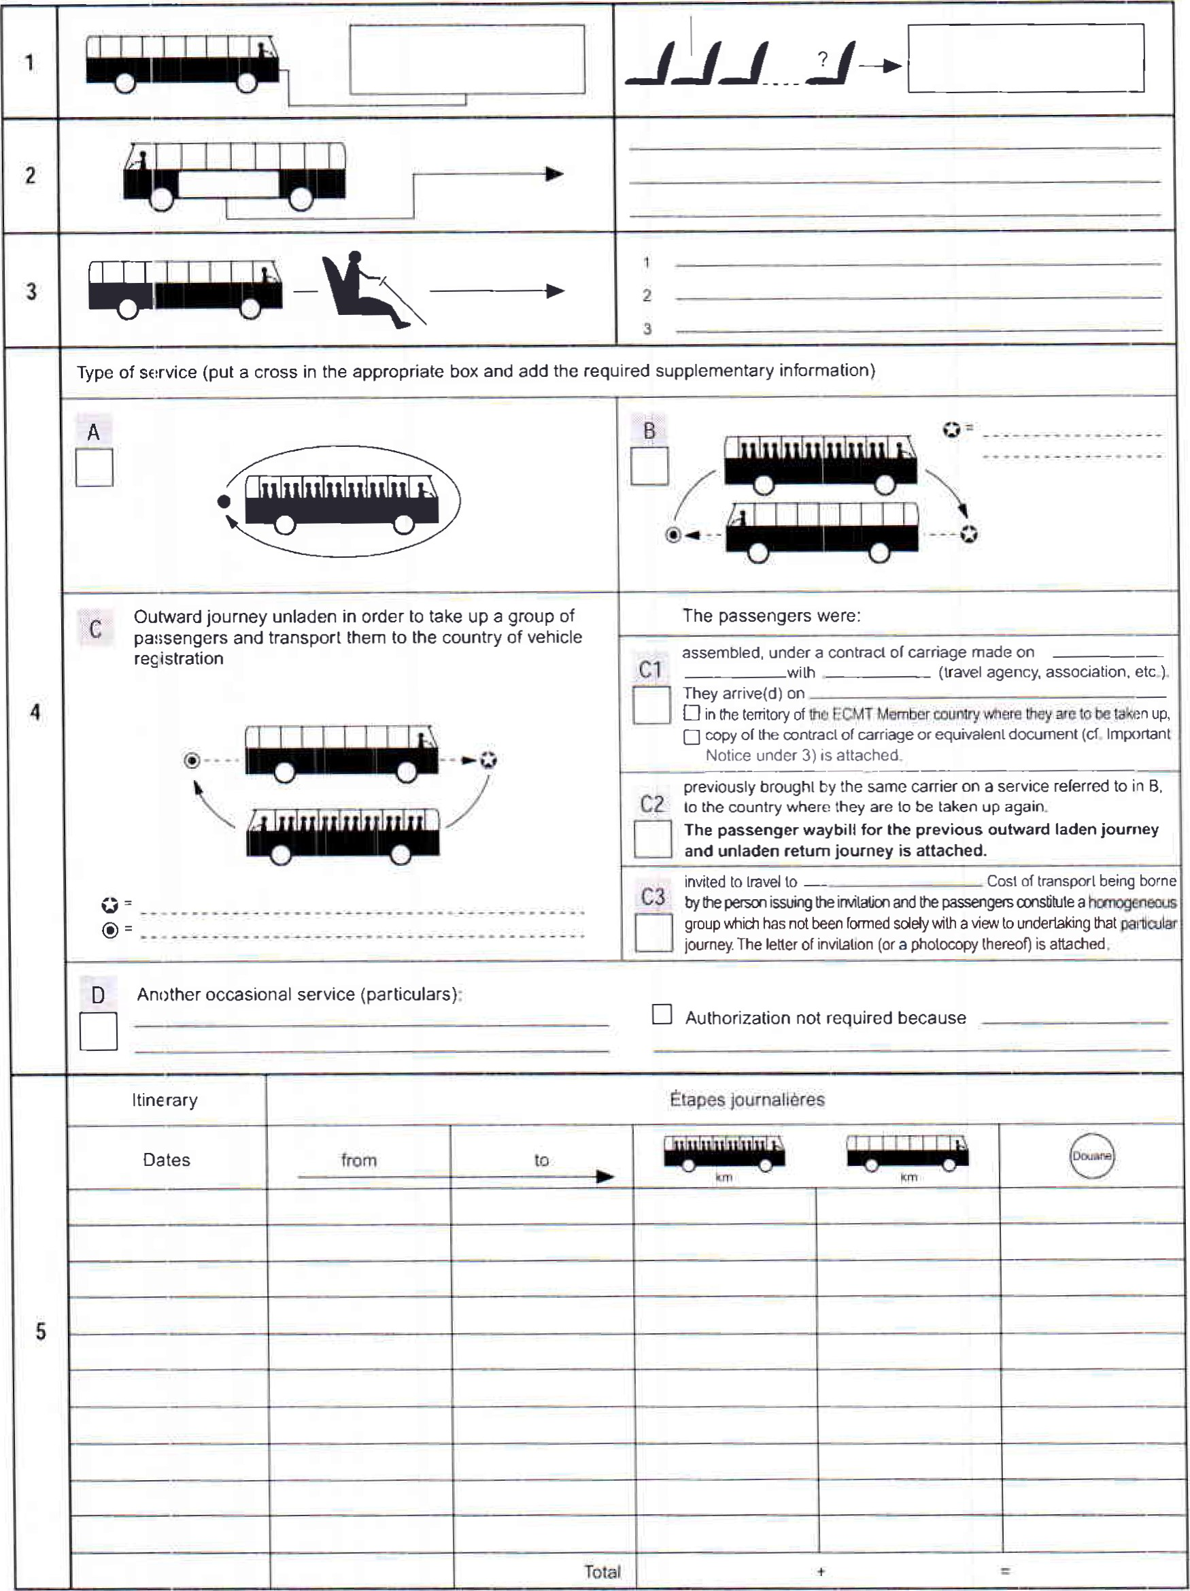

(Passenger waybill — verso)

